

USER GUIDE

ORIGINAL INSTRUCTIONS

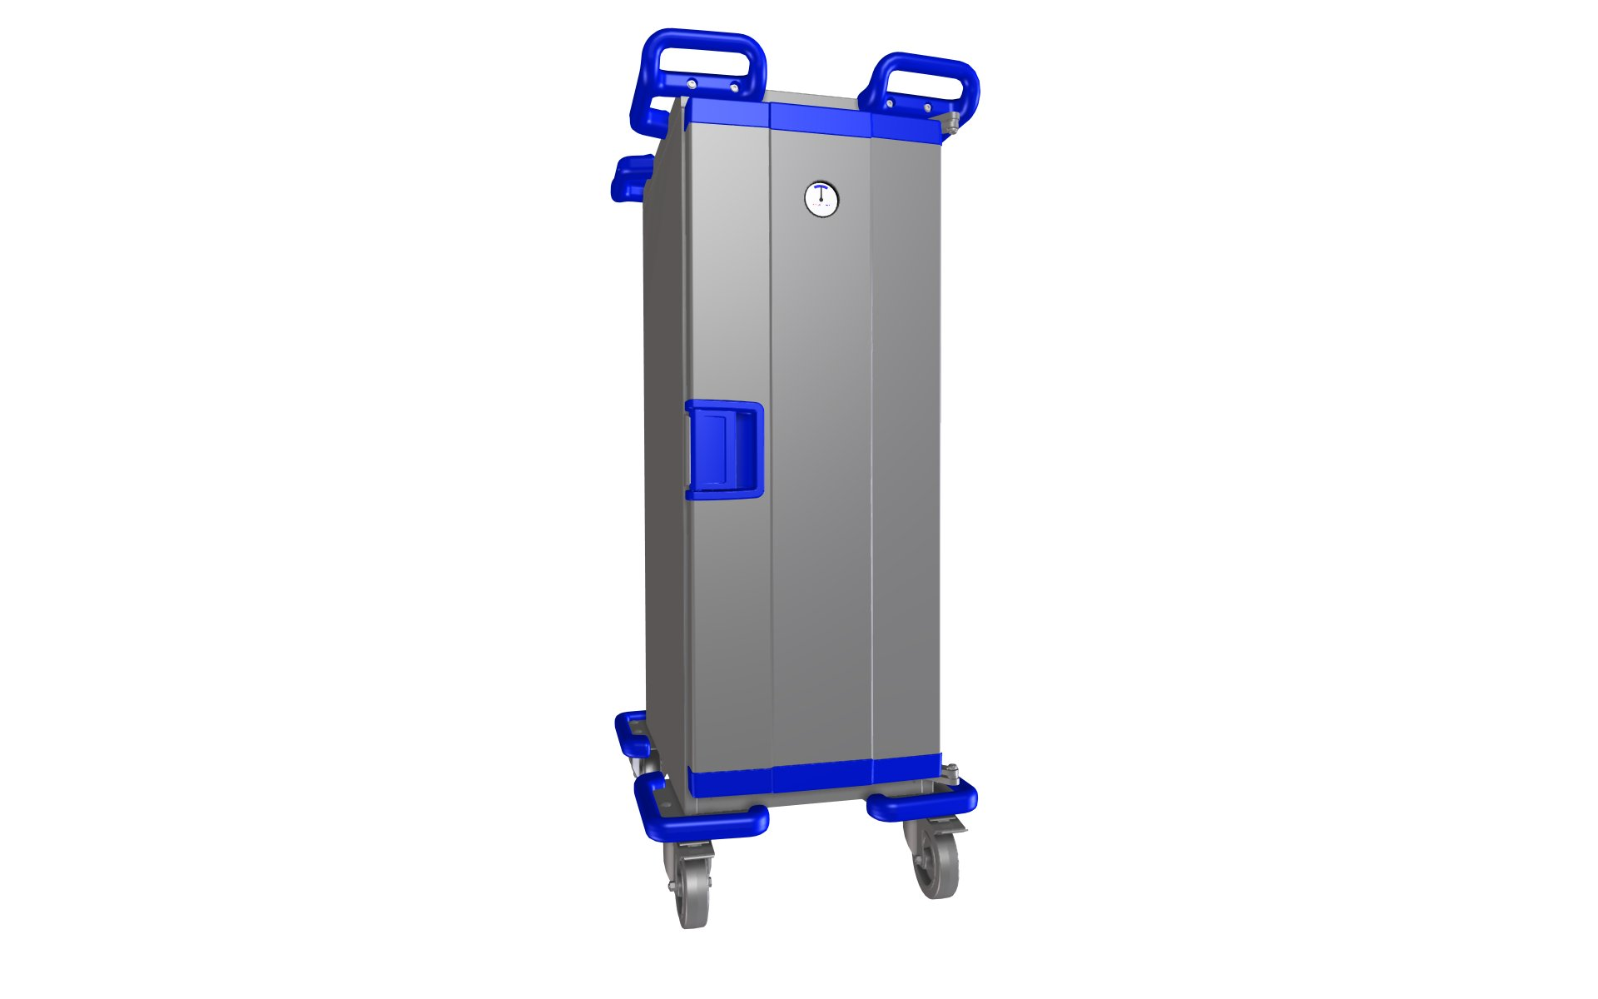

**AB Hallins Verkstäder**

**Box 24**

**SE-599 21 ÖDESHÖG**

**Tel.:**  **+46 (0)144-15300**

**Fax:**  **+46 (0)144-31400**

**Email:**  [**support@hallins.com**](mailto:support@hallins.com) Version: 1.0

**Web:**  [**www.hallins.com**](http://www.hallins.com/) **or**  [**www.temptainer.se**](http://www.temptainer.se/) Date: 04/02/2013

# CONTENTS

[1. CONTENTS 2](#_Toc350863343)

[2. TEMPTAINER - OVERVIEW 3](#_Toc350863344)

[OVERVIEW - FEATURES COMMON TO ALL MODELS: 3](#_Toc350863345)

[3. INTRODUCTION 4](#_Toc350863346)

[4. DELIVERY AND ASSEMBLY 5](#_Toc350863347)

[5. WARRANTY 6](#_Toc350863348)

[6. USE 7](#_Toc350863349)

[SAFETY 7](#_Toc350863350)

[IMPORTANT – for trolleys with active heating and cooling 8](#_Toc350863351)

[BEFORE STARTING WORK 8](#_Toc350863352)

[DURING WORK 8](#_Toc350863353)

[TEMPTAINER WITH HEATING 9](#_Toc350863354)

[TEMPTAINER WITH PELTIER ACTIVE COOLING TECHNOLOGY 9](#_Toc350863355)

[TEMPTAINER WITH COMPRESSOR ACTIVE COOLING TECHNOLOGY 10](#_Toc350863356)

[TEMPTAINER WITH COMBINED ACTIVE HEATING AND ACTIVE COOLING 11](#_Toc350863357)

[TEMPTAINER IN NEUTRAL DESIGN 11](#_Toc350863358)

[TRANSPORT 11](#_Toc350863359)

[7. MAINTENANCE AND TROUBLESHOOTING 13](#_Toc350863360)

[CLEANING 13](#_Toc350863361)

[MAINTENANCE 14](#_Toc350863362)

[TROUBLESHOOTING 14](#_Toc350863363)

[8. OVERVIEW AND TECHNICAL DATA 15](#_Toc350863364)

[OVERVIEW – general information 15](#_Toc350863365)

[DIGITAL DISPLAY – CONTROL 15](#_Toc350863366)

[ANALOGUE DISPLAY 16](#_Toc350863367)

[SINGLE 17](#_Toc350863368)

[TOWER 19](#_Toc350863369)

[TWIN 21](#_Toc350863370)

[9. SPARE PARTS 23](#_Toc350863371)

[10. STICKERS 26](#_Toc350863372)

[11. ACCESSORIES 27](#_Toc350863373)

[12. OPERATION BOOK - SERVICE AND MAINTENANCE 29](#_Toc350863374)

[13. RECYCLING 30](#_Toc350863375)

[14. EU DECLARATION OF CONFORMITY 31](#_Toc350863376)

# TEMPTAINER - OVERVIEW

This manual covers all versions of the **Temptainer** (also referred to as the **trolley** in this manual). Unless otherwise stated, the information is generally applicable.

## OVERVIEW - FEATURES COMMON TO ALL MODELS:

**Innovative design with functionality down to the smallest detail**

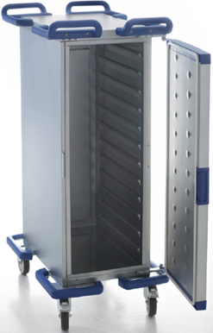

**Shock-absorbent bumpers to protect trolley and environment**

**Strong wheels for various surfaces and environments**

**Simplicity and clarity in every detail and function**

**Concealed heating element with even temperature distribution**

**Level surface with load securing options**

**Washable interior and exterior for easier, safer cleaning and hygiene**

**40 mm insulation made of high-pressure polyurethane foam for optimal temperature preservation**

**Low energy consumption**

**Deep-drawn multifunctional guides with no joints where dirt can gather**

**Innovative stainless design with level surfaces, high durability and supreme hygiene properties**

**Air vents for internal air circulation and even temperature distribution**

**User-friendly handles with shock-absorbing and protective function**

**Detachable door seal**

**Door opens to 270°**

**Door lock with single-handle operation**

# INTRODUCTION

Use and layout are generally the same for all models; any significant differences are shown in the text and pictures.

Please remember that: **Only qualified personnel may use the trolley!**

Before using the trolley for the first time, the operator is obliged to study and then observe the instructions in this manual.

The correct use, operation, inspections and maintenance of this machine are critical for executing your work effectively and safely and for the trolley's useful life.

This manual must be available to all relevant personnel, be kept in a protected place and accompany the product if transferred to another location.

If you have any questions – contact your supplier.

The relevant part number and serial number may be found on the trolley's machine plate.

**The following symbol is used in this manual:**



**IMPORTANT!**

* to emphasise important information or warn of potential risks, etc.

# DELIVERY AND ASSEMBLY

When the trolley arrives at your location, it has been checked, tested and cleaned in the factory.

As the recipient of this shipment, it is very important that you check the shipment immediately on arrival!

The following points must be checked immediately upon receipt:

* Check that the shipment is intact! Check that there are no visible damage/defects on the shipment. Shipment = Packaging and product.
* Check that the quantity is correct.
* Check that it is the correct product.

Any deviations from the above must ALWAYS and IMMEDIATELY be noted on the consignment note before acknowledging receipt of the shipment to the carrier!

Also contact Hallins, ideally at once but no later than three days after receipt of the shipment.

**Tel.:** +46 144 15 300 (ask for Sales Support).

**Email:** claim@hallins.com

Temptainers are normally delivered upright on a pallet, enclosed in protective plastic and secured with plastic straps (although this may vary slightly, depending on the delivery method).

 **IMPORTANT!**

When removing the packaging, take care to ensure that the power cable is not damaged.

 After unpacking, hand the packaging materials in for proper recycling.

**NOTE!**

Always clean the trolley before use!

# WARRANTY

The manufacturer will rectify any faults that can be attributed to production or material faults and that occur within 24 months of delivery.

The warranty also applies in accordance with the following provisions:

**BFS 2009** General provisions for the supply of catering equipment.

**NL 09** General provisions for the supply of machinery and other mechanical, electrical and electronic equipment.

**ORGALIME 2012** General provisions for the supply of machinery and other mechanical, electrical and electronic equipment.

In addition to the basic warranty period of 24 months, Hallins offers an extended warranty of 36 months for Temptainers with active heating (2+3 years).

This extended warranty period is only valid, however, for faults that can be attributed to the heating element.

# USE

The Temptainer is designed to be used for the transport of food in an indoor environment under normal conditions in terms of temperature, humidity and lighting.

The surface should be level, hard and non-slip and have no cavities or obstructions.

The Temptainer should normally be moved by hand, although some versions may also be moved in a chain.

If necessary the Temptainer can be transported between different indoor environments using, for example, a truck or another covered vehicle.

In order to utilise the qualities of the trolley to the greatest effect and to prevent injury, it is vital that you read through these instructions carefully and that you use the trolley in the correct way.

## SAFETY

The trolley has been designed and fitted with safety devices to prevent and avoid injury and accidents.

The safety devices must not be put out of service or removed.

Modifications to the trolley that affect operational safety are not permitted.

It is extremely important that users are familiar with how the trolley works and the correct way to use it.

The rules of the Swedish Occupational Safety Authority [Arbetsskyddsverket] must always be observed, minimum requirements in accordance with *Directive* ***2009/104/EC***.

 **IMPORTANT**

The food trolley may only be used for its intended purpose and by people who are qualified to use it.

Never use the trolley if damage or faults have occurred that affect operational safety. Never use the trolley if it has been repaired, modified or adjusted without the approval of the person responsible. Faults in the trolley and deficiencies in the working environment must be reported to a supervisor.

Remember that you as user are responsible for ensuring no one is injured.

The trolley must be used in such a way that injury to persons or damage to property does not occur.

* Signs and markings must not be removed or made illegible.
* The trolley must undergo preventive maintenance on a regular basis for the purpose of avoiding accidents. Read more about maintenance in Chapter 7.

 **IMPORTANT**

When using in public environments, particularly where children may be present, the user must take adequate measures to prevent people from entering the work area.

We recommend that a risk analysis be prepared for the environment in question.

## C:\Users\test\Desktop\Temptainer manualer 2012\IMG_3392.JPGsign_importanceIMPORTANT – for trolleys with active heating and cooling

There must always be an air gap between the base of the food trolley and the closest food container.

The base **must not be used as a storage space** for objects such as, for example, *plates, serving dishes, pans, etc.*

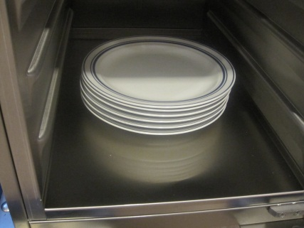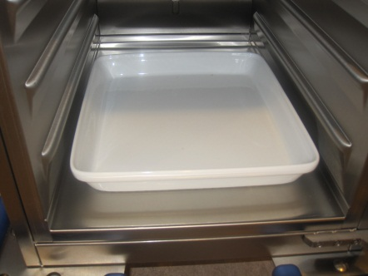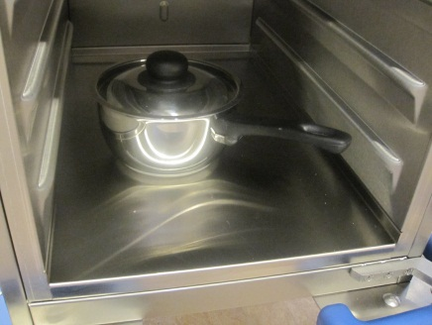

**Do not cover the base!**

## 

## BEFORE STARTING WORK

* Make sure that the trolley is used on a firm, smooth surface.
* Always use protective shoes, gloves and clothing as required.

## DURING WORK

* Maintain full supervision of the trolley when it is moving. Look out for other mobile machines and objects in the vicinity.
* Be aware of the risk of tipping! The trolley may only carry loads for which it is designed, and these loads must be stable and securely arranged.
* Do not let the trolley come into contact with other objects.
* Be aware of the risk of trapping when working with trolleys on wheels.
* It is forbidden to travel on the trolley.
* When the trolley is parked or left unsupervised, the wheel brake must always be locked.

**Wheel with a foot brake**

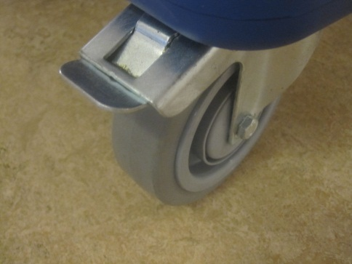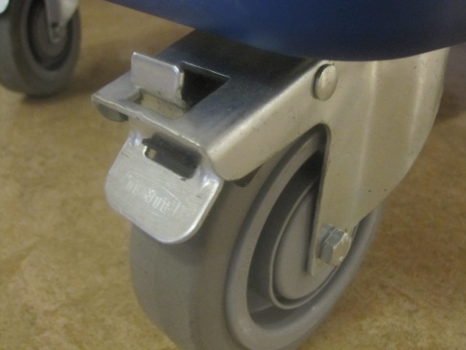

The brake when locked. The brake when released.

## TEMPTAINER WITH HEATING

|  |  |
| --- | --- |
| 1. | Connect the power cable to an earthed electrical socket (230-240 V~) to start the heating process.  **NOTE!**  The trolley should be switched on approx. 40 minutes before use so that the temperature reaches the right heating temperature (approx. +85°C).  The trolley has a preset thermostat, which may only be changed by a qualified service engineer. |
| 2. | The temperature indicator on the door of the trolley shows when the preset temperature has been reached in the trolley.  **NOTE!**  The trolley is fitted with overheat protection, which disconnects the electricity supply if the temperature is too high and return to normal operation takes place automatically. |
| 3. | When the temperature in the trolley has reached the right level, vessels containing hot food may be placed in the trolley. |

|  |  |
| --- | --- |
| 4. | Only place well heated items in the hot cabinet.  **Bear in mind!** Use containers with lids for the best temperature retention and avoid opening them and the doors unnecessarily. The better the areas are filled, the better the ability to maintain the correct temperature. |
| 5. | Conclude the heating up process by detaching the power cable from the electricity socket. |

## TEMPTAINER WITH PELTIER ACTIVE COOLING TECHNOLOGY

The Peltier cooling technology use the ambient environment to generate cooling. There is a restriction of the cooling capacity, which is approx. 22 degrees below the ambient temperature.

|  |  |
| --- | --- |
| 1. | Connect the power cable to an earthed electrical socket (230-240 V~) to start the cooling process.  The trolley should be switched on approx. 40 minutes before use so that the temperature reaches the right cooling temperature (approx. +4°C).  The trolley has a preset thermostat, which may only be changed by a qualified service engineer.  **NOTE!**  The rear side of the trolley must have clearance from the wall or other objects of at least 5 cm. |
| 2. | The temperature indicator on the front shows when the trolley has reached the preset temperature (approx. +4°C).  If your trolley has an analogue indicator without digits, the black needle must be pointing at the left edge of the blue field. |
| 3. | When the temperature in the trolley has come down to the right level, vessels containing food may be placed in the trolley. |
| 4. | Only place well cooled items in the cold cabinet.   **Bear in mind!**  Use containers with lids for the best temperature retention and avoid opening them and the doors unnecessarily. The better the areas are filled, the better the ability to maintain the correct temperature. |
| 5. | Conclude the cooling process by detaching the power cable from the electricity socket. |

## TEMPTAINER WITH COMPRESSOR ACTIVE COOLING TECHNOLOGY

|  |  |
| --- | --- |
| 1. | Connect the power cable to an earthed electrical socket (230-240 V~) to start the cooling process.  The trolley should be switched on approx. 40 minutes before use so that the temperature reaches the right cooling temperature (approx. +4°C).  The trolley has a preset thermostat, which may only be changed by a qualified service engineer.  **NOTE!**  The rear side of the trolley must have clearance from the wall or other objects of at least 5 cm. |
| 2. | The temperature indicator on the front shows when the trolley has reached the preset temperature (approx. +4°C).  If your trolley has an analogue indicator without digits, the black needle must be pointing at the left edge of the blue field. |
| 3. | When the temperature in the trolley has come down to the right level, vessels containing food may be placed in the trolley. |
| 4. | Only place well cooled items in the cold cabinet.  **Bear in mind!**  Use containers with lids for the best temperature retention and avoid opening them and the doors unnecessarily. The better the areas are filled, the better the ability to maintain the correct temperature. |
| 5. | Conclude the cooling process by detaching the power cable from the electricity socket. |

## TEMPTAINER WITH COMBINED ACTIVE HEATING AND ACTIVE COOLING

|  |  |
| --- | --- |
| 1. | Connect the power cable to an earthed electrical socket (230-240 V~) to start the cooling/heating process.  The trolley should be switched on approx. 40 minutes before use in order to come down to the right cooling temperature (approx. +4°C) or heating temperature (approx. +85°C).  The trolley has a preset thermostat, which may only be changed by a qualified service engineer.  **NOTE!**  The rear side of the trolley must have clearance from the wall or other objects of at least 5 cm. |
| 2. | The temperature indicator on the front shows when the trolley has reached the preset temperature.  If your trolley has an analogue indicator with no digits, the black indicator must be pointing at the left edge of the blue field for a cabinet with cooling, and at the right part of the red field for a cabinet with heating. |
| 3. | When the temperature in the trolley has come up/down to the right level, vessels containing hot or cold food may be placed in the relevant trolley. |
| 4. | Only place well cooled items in the cold cabinet.   **Bear in mind!** Use containers with lids for the best temperature retention and avoid opening them and the doors unnecessarily. The better the areas are filled, the better the ability to maintain the correct temperature. |
| 5. | Conclude the cooling/heating process by detaching the power cable from the electricity socket. |

## TEMPTAINER IN NEUTRAL DESIGN

The Temptainer in neutral design has neither active cooling nor heating, but is used primarily to transport food.

It is, however, easier to maintain the temperature of the food using the trolley.

In order to maintain the low temperature of cooled items, the trolley may be placed in a cold room before use and fitted with cooling and freezing lamps.

## TRANSPORT

The Temptainer is designed to be used to transport food in an indoor environment.

The Temptainer is normally transported or moved by hand, although some versions may also be moved in a chain.

This kind of transport uses a pulling device consisting of a pin and tow-bar, which are available as options from Hallins.

The maximum number of trolleys that may be connected in a chain is six.

If necessary, the Temptainer can be transported or moved between different indoor environments using, for example, a truck or another covered vehicle.

 **IMPORTANT**

It is very important to secure the trolley in the vehicle using suitable equipment to make sure that there is no risk of the trolley tipping over during vehicle transport!

Whatever the means of the transport, the surface must be level, hard and non-slip and have no cavities or obstructions.

# MAINTENANCE AND TROUBLESHOOTING

This chapter describes the maintenance required for the trolley to function in the best way possible as well as troubleshooting for rectification by the user.

In addition to this manual, it is possible that we may send separate instructions that accompany the trolley in terms of maintenance and troubleshooting.

**NOTE!**

Only Hallins original spare parts may be used when replacing parts. Failure to observe this may nullify the warranty obligation in full.

## CLEANING



**IMPORTANT**

Under no circumstances may the Temptainer be connected to the mains supply during cleaning. Always remove the mains cable from the electrical socket before cleaning.

As the Temptainer contains electrical components, it is very important that cleaning is carried out with care.

The Temptainer may be cleaned using standard detergents used in restaurants and catering operations.

**NOTE!**

Corrosive detergents may not be used.

|  |  |  |  |
| --- | --- | --- | --- |
| **Model** | **IP class, internal** | **IP class, external** | **Cleaning permitted** |
| Neutral (**N)** | IPXX | IPXX | May be rinsed with water both internally and externally. |
| Active heating (**H**) | IP65 | IP55 | May be rinsed with water both internally and externally. |
| Active cooling (**C**) | IP55 | IP20 | May be rinsed with water internally, external cleaning with damp cloth. |
| Active cooling (**C**) | IP65 | IP23 | May be rinsed with water internally, external cleaning with spraying water. |
| Active heating +  Active cooling (**H+C**) | IP55 | IP20 | May be rinsed with water internally, external cleaning with damp cloth. |

## MAINTENANCE

In order for your Temptainer to work in the best possible way, it is important to perform regular maintenance in accordance with the following.



**IMPORTANT**

Check that the trolley is not connected to the mains when commencing maintenance.

|  |  |
| --- | --- |
| **Frequency** | **Procedure** |
| Each day | 1. Clean the trolley in accordance with cleaning instructions. |
|  | 1. Check that the trolley's electrical components and flex holder are free from defect. |
|  | 1. Check that signs and marks are intact and legible. |
| Every month | 1. Check all electrical connections and components and rectify any damage and wear. Replace with new parts where necessary. |
|  | 1. Check that all screws and nuts are properly tightened. |
|  | 1. Check that all wheels rotate freely and that the tyre coating is intact. |
|  | 1. Check that the wheel brakes are undamaged and work properly. 2. Check the fan in the trolley with Peltier cooling, clean as required. |

## TROUBLESHOOTING

The trolley has been designed and tested to achieve optimal operational reliability and service life, under the proviso that regular maintenance is carried out in accordance with the specified instructions. If despite this a problem should occur, use the troubleshooting list below to obtain relevant guidance.

If problems persist after you have taken the measures specified in the list below, you should contact an authorised service engineer or AB Hallins Verkstäder.

|  |  |
| --- | --- |
| **Symptom** | **Procedures** |
| Trolley with active heating does not heat up. | A. Check that the flex holder is connected to the mains. |
|  | B. Check that the flex holder has not been damaged. |
|  | C. Check that the connections in the trolley and flex holder are intact. |
|  | D. Contact a qualified service engineer. |
| Trolley with active cooling does not cool down. | A. Check that the flex holder is connected to the mains. |
|  | B. Check that the flex holder has not been damaged. |
|  | C. Check that the connections in the trolley and flex holder are intact.  D. Check that the fans in trolleys with Peltier cooling are clean. |
|  | E. Contact a qualified service engineer. |

# OVERVIEW AND TECHNICAL DATA

## OVERVIEW – general information

The Temptainer from Hallins is available in several sizes. The size of the trolleys is described using the number of guides, from 4 to 14 guides, with guide gaps of 80 mm. The trolleys are adapted to gastronorm standards and only gastronorm containers, trays, etc. may be used.

There are three different models, **Single, Tower** and **Twin**,

each of which can have the following functions:

* neutral (**N**),
* active heating (**H**),
* active cooling (**C**),
* or a combination of these.

Cooling is based on either Peltier technology (**C**) or compressor technology (**CC**).

The Neutral (**N**) trolley has no active heating or cooling function.

## DIGITAL DISPLAY – CONTROL

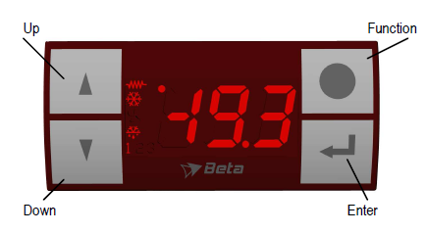

UP

ENTER

DOWN

FUNCTION

Certain Temptainers with active heating and active cooling can be fitted with one or more combined digital temperature indicators/thermostats.

The digital display for active **heating** has a display with **red** digits and symbols.

The digital display for active **cooling** has a display with **blue** digits and symbols.

The digital display always shows the preset value. The normal value for Temptainers with active heating is +85°C. The normal value for Temptainers with active cooling is +4°C.

**NOTE!**  The displays are only active when the product's mains cable is connected to the mains!

Below is an explanation of the symbols that appear in the display on each indicator:



**Constant light: Cooling under way. Disappears when the desired temperature has been reached.**

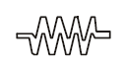

**Constant light: Heating under way. Disappears when the desired temperature has been reached.**

**Flashing light: Flashes while the preset TARGET value is being set with the UP or DOWN buttons pressed in. See description below.**

**Adjusting the temperature:**

It is possible to adjust the temperatures (TARGET value) for each temperature and thermostat. The thermostat for active heating can be adjusted in the range +X°C to +85°C. The thermostat for active cooling can be adjusted in the range +-0°C to +8°C.

**For higher temperature:**

Press the UP button until the desired value is shown in the display. As soon as the button is pressed in, a dot in the top left-hand corner starts to flash. Once the desired value is visible in the display, wait a moment until the dot stops flashing and disappears. The new value has now been set!

## ANALOGUE DISPLAY

Some of the food trolleys are fitted with an analogue temperature indicator.

**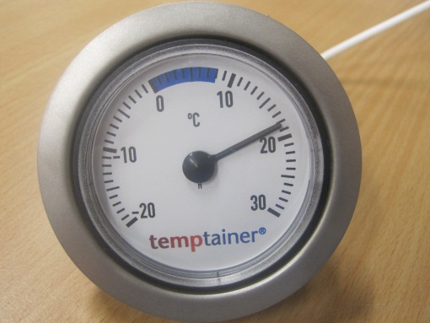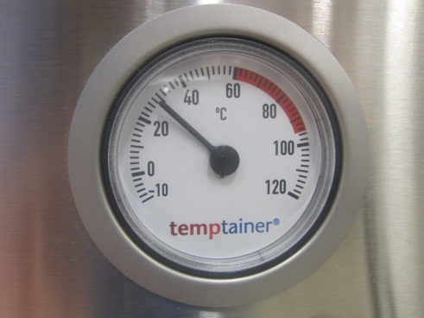**

Cabinet with active heating (H). Cabinet with active cooling (C).

**TECHNICAL DATA – specific information**

## SINGLE

The Single model is a trolley in either cooling (**C or CC**), heating (**H**) or neutral (**N**) version.

*Figure 1. Single model with active compressor cooling (CC).*

**Front** **Back**

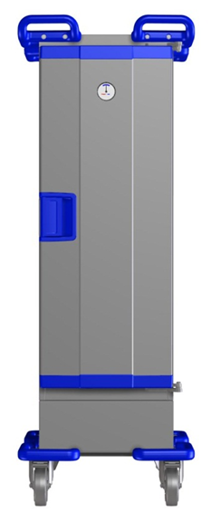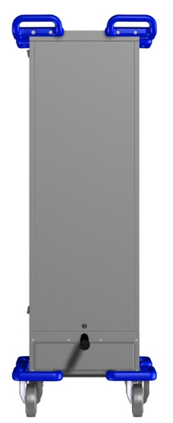

2

3

1

4

5

1

4

6

|  |  |
| --- | --- |
|  |  |

|  |  |  |  |
| --- | --- | --- | --- |
| **Figure 1. Main parts of Temptainers in Single design** | | | |
|  | | | |
| 1 | Handle/bumper | 4 | Bumper |
| 2 | Temperature indicator | 5 | Wheel with foot brake |
| 3 | Handle/door lock | 6 | Power cable (not in neutral trolley) |

|  |  |  |  |  |  |  |
| --- | --- | --- | --- | --- | --- | --- |
| Technical data – **Single N** | M6011100 | M6011200 | M6011300 | M6011400 | M6011500 | M6011600 |
| **Guide pair (qty)** | 4 | 6 | 8 | 10 | 12 | 14 |
| **Width x depth (mm)** | 537x725 | 537x725 | 537x725 | 537x725 | 537x725 | 537x725 |
| **Height (mm)** | 695 | 855 | 1015 | 1175 | 1335 | 1495 |
| **Weight (kg)** | 35 | 40 | 45 | 50 | 55 | 60 |
| **Capacity (litres)** | 40 | 60 | 80 | 100 | 120 | 140 |
| **Wheel diameter (mm)** | 125 | 125 | 125 | 125 | 125 | 125 |

|  |  |  |  |  |  |
| --- | --- | --- | --- | --- | --- |
| Technical data – **Single H** | M6012100 | M6012200 | M6012300 | M6012400 | M6012500 |
| **Guide pair (qty)** | 4 | 6 | 8 | 10 | 12 |
| **Width x depth (mm)** | 537x725 | 537x725 | 537x725 | 537x725 | 537x725 |
| **Height (mm)** | 695 | 855 | 1015 | 1175 | 1335 |
| **Weight (kg)** | 35 | 40 | 45 | 50 | 55 |
| **Capacity (litres)** | 40 | 60 | 80 | 100 | 120 |
| **Output (W) 230-240 V, 50-60 Hz, 1-phase** | 234 | 324 | 384 | 474 | 564 |
| **Wheel diameter (mm)** | 125 | 125 | 125 | 125 | 125 |

|  |  |  |  |  |  |
| --- | --- | --- | --- | --- | --- |
| Technical data – **Single C** | M6013200 | M6013300 | M6013400 | M6013500 | M6013600 |
| **Guide pair (qty)** | 6 | 8 | 10 | 12 | 14 |
| **Width x depth (mm)** | 537x810 | 537x810 | 537x810 | 537x810 | 537x810 |
| **Height (mm)** | 855 | 1015 | 1175 | 1335 | 1495 |
| **Weight (kg)** | 50 | 55 | 60 | 65 | 70 |
| **Capacity (litres)** | 60 | 80 | 100 | 120 | 140 |
| **Output (W) 230-240 V, 50-60 Hz, 1-phase** | 135 | 135 | 135 | 135 | 135 |
| **Wheel diameter (mm)** | 125 | 125 | 125 | 125 | 125 |

|  |  |
| --- | --- |
| Technical data – **Single CC** | M6013700 |
| **Guide pair (qty)** | 12 |
| **Width x depth (mm)** | 537x725 |
| **Height (mm)** | 1495 |
| **Weight (kg)** | 83 |
| **Capacity (litres)** | 120 |
| **Output (W) 230-240 V, 50-60 Hz, 1-phase** | 135 |
| **Wheel diameter (mm)** | 125 |

## 

## TOWER

The Tower trolley has double compartments, stacked. The compartment can be combined in any way for cold, hot or neutral storage.

The active cooling is based on Peltier technology.

*Figure 2. Tower model with active heating and neutral compartment.*

**Front** **Back**

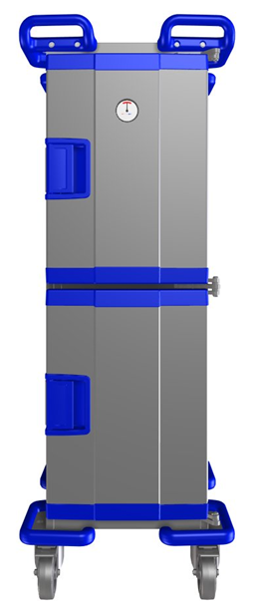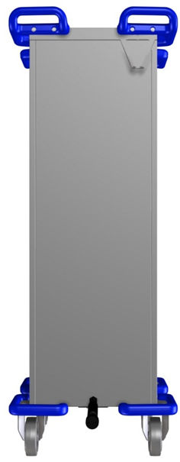

2

3

1

4

5

1

4

7

6

|  |  |  |  |
| --- | --- | --- | --- |
| **Figure 2. Main parts of Temptainer in Tower design** | | | |
| 1 | Handle/bumper | 5 | Wheel with foot brake |
| 2 | Temperature indicator | 6 | Bracket for cable |
| 3 | Handle/door lock |  | (not in neutral trolley) |
| 4 | Bumper | 7 | Power cable (not in neutral trolley) |
|  | | | |

### 

### 

|  |  |  |  |  |  |
| --- | --- | --- | --- | --- | --- |
| Technical data – **Single N+H** | M6014100 | M6014200 | M6014300 | M6014400 | M6014500 |
| **Guide pair (qty)** | 4+4 | 4+6 | 4+8 | 6+6 | 6+8 |
| **Width x depth (mm)** | 537x725 | 537x725 | 537x725 | 537x725 | 537x725 |
| **Height (mm)** | 1109 | 1269 | 1429 | 1429 | 1589 |
| **Weight (kg)** | 55 | 59 | 62 | 62 | 66 |
| **Capacity (litres)** | 40+40 | 40+60 | 40+80 | 60+60 | 60+80 |
| **Output (W) 230-240 V, 50-60 Hz, 1-phase** | 234 | 324 | 384 | 324 | 384 |
| **Wheel diameter (mm)** | 125 | 125 | 125 | 125 | 125 |

|  |  |  |  |  |  |
| --- | --- | --- | --- | --- | --- |
| Technical data – **Tower H+H** | M6015100 | M6015200 | M6015300 | M6015400 | M6015500 |
| **Guide pair (qty)** | 4+4 | 6+4 | 6+6 | 8+4 | 8+6 |
| **Width x depth (mm)** | 537x725 | 537x725 | 537x725 | 537x725 | 537x725 |
| **Height (mm)** | 1109 | 1269 | 1429 | 1429 | 1589 |
| **Weight (kg)** | 55 | 59 | 62 | 62 | 66 |
| **Capacity (litres)** | 40+40 | 40+60 | 40+80 | 60+60 | 60+80 |
| **Output (W) 230-240 V, 50-60 Hz, 1-phase** | 234+234 | 324+234 | 324+324 | 384+234 | 384+324 |
| **Wheel diameter (mm)** | 125 | 125 | 125 | 125 | 125 |

|  |  |  |  |  |  |
| --- | --- | --- | --- | --- | --- |
| Technical data – **Tower C+H** | M6016100 | M6016200 | M6016300 | M6016400 | M6016500 |
| **Guide pair (qty)** | 6+4 | 6+6 | 8+4 | 8+6 | 4+6 |
| **Width x depth (mm)** | 537x810 | 537x810 | 537x810 | 537x810 | 537x810 |
| **Height (mm)** | 1269 | 1429 | 1429 | 1589 | 1269 |
| **Weight (kg)** | 69 | 72 | 72 | 76- | 69 |
| **Capacity (litres)** | 60+40 | 40+40 | 80+40 | 80+60 | 40+60 |
| **Output (W) 230-240 V, 50-60 Hz, 1-phase** |  | 135+324 | 135+234 | 135+324 | 135+324 |
| **Wheel diameter (mm)** |  | 125 | 125 | 125 | 125 |

|  |  |  |
| --- | --- | --- |
| Technical data – **Tower C+H** | M6016600 | M6016700 |
| **Guide pair (qty)** | 4+4 | 4+8 |
| **Width x depth (mm)** | 537x810 | 537x810 |
| **Height (mm)** | 1109 | 1429 |
| **Weight (kg)** | 65 | 72 |
| **Capacity (litres)** | 40+40 | 40+80 |
| **Output (W) 230-240 V, 50-60 Hz, 1-phase** | 135+234 | 135+324 |
| **Wheel diameter (mm)** | 125 | 125 |

## TWIN

The Twin has double compartments, side by side. The compartments can be combined in any way for cold, hot or neutral storage. The active cooling is based on Peltier technology.

*Figure 3. Twin model with active Peltier cooling and active heating.*

**Front** **Back**

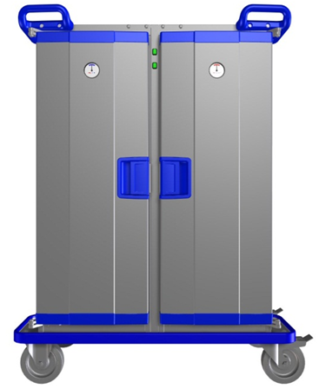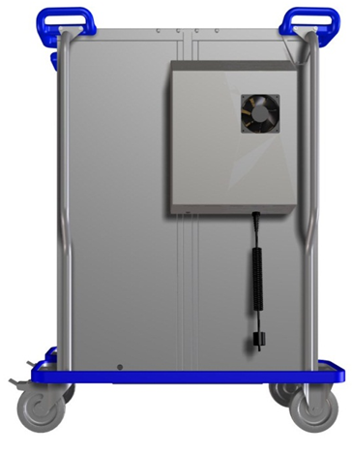

2

3

1

4

5

1

5

8

9

6

6

7

|  |  |  |  |
| --- | --- | --- | --- |
|  | |  | |
| **Figure 3. Main parts of Temptainer in Twin design** | | | |
| 1 | Handle/bumper | 6 | Wheel with foot brake |
| 2 | ON/OFF indicator (option) | 7 | Bracket for cable |
| 3 | Temperature indicator | 8 | Peltier cooling unit (only on trolleys with Peltier cooling) |
| 4 | Handle/door lock | 9 | Power cable (not in neutral trolley) |
| 5 | Bumper |  |  |
|  | | | |

### 

|  |  |  |  |
| --- | --- | --- | --- |
| Technical data – **Temptainer Twin N+H** | M6017100 | M6017200 | M6017300 |
| **Guide pair (qty)** | 8+8 | 10+10 | 12+12 |
| **Width x depth (mm)** | 1012x738 | 1012x738 | 1012x738 |
| **Height (mm)** | 1057 | 1217 | 1377 |
| **Weight (kg)** | 96 | 106 | 116 |
| **Capacity (litres)** | 80+80 | 100+100 | 120+120 |
| **Output (W) 230-240 V, 50 Hz, 1-phase** | 384 | 474 | 564 |
| **Wheel diameter (mm)** | 160 | 160 | 160 |

|  |  |  |  |
| --- | --- | --- | --- |
| Technical data – **Temptainer Twin H+H** | M6018100 | M6018200 | M6018300 |
| **Guide pair (qty)** | 8+8 | 10+10 | 12+12 |
| **Width x depth (mm)** | 1012x738 | 1012x738 | 1012x738 |
| **Height (mm)** | 1057 | 1217 | 1377 |
| **Weight (kg)** | 96 | 106 | 116 |
| **Capacity (litres)** | 80+80 | 100+100 | 120+120 |
| **Output (W) 230-240 V, 50 Hz, 1-phase** | 384+384 | 474+474 | 564+564 |
| **Wheel diameter (mm)** | 160 | 160 | 160 |

|  |  |  |  |
| --- | --- | --- | --- |
| Technical data – **Temptainer Twin C+H** | M6019100 | M6019200 | M6019300 |
| **Guide pair (qty)** | 8+8 | 10+10 | 12+12 |
| **Width x depth (mm)** | 1012x810 | 1012x810 | 1012x810 |
| **Height (mm)** | 1057 | 1217 | 1377 |
| **Weight (kg)** | 112 | 122 | 132 |
| **Capacity (litres)** | 80+80 | 100+100 | 120+120 |
| **Output (W) 230-240 V, 50 Hz, 1-phase** | 384+384 | 474+474 | 564+564 |
| **Wheel diameter (mm)** | 160 | 160 | 160 |

|  |  |  |  |  |
| --- | --- | --- | --- | --- |
| Technical data – **Temptainer Twin C+C** | M6019500 | M6019600 | M6019700 | M6019800 |
| **Guide pair (qty)** | 8+8 | 10+10 | 12+12 | 14+14 |
| **Width x depth (mm)** | 1012x810 | 1012x810 | 1012x810 | 1012x810 |
| **Height (mm)** | 1057 | 1217 | 1377 | 1537 |
| **Weight (kg)** | 117 | 127 | 137 | 147 |
| **Capacity (litres)** | 80+80 | 100+100 | 120+120 | 140+140 |
| **Output (W) 230-240 V, 50 Hz, 1-phase** | 135+135 | 135+135 | 135+135 | 135+135 |
| **Wheel diameter (mm)** | 160 | 160 | 160 | 160 |

|  |  |  |  |  |
| --- | --- | --- | --- | --- |
| Technical data – **Temptainer Twin N+N** | M6017500 | M6017600 | M6017700 | M6017800 |
| **Guide pair (qty)** | 8+8 | 10+10 | 12+12 | 14+14 |
| **Width x depth (mm)** | 1012x810 | 1012x810 | 1012x810 | 1012x810 |
| **Height (mm)** | 1057 | 1217 | 1377 |  |
| **Weight (kg)** | 117 | 127 | 137 |  |
| **Capacity (litres)** | 80+80 | 100+100 | 120+120 |  |
| **Output (W) 230-240 V, 50 Hz, 1-phase** | 135+135 | 135+135 | 135+135 | 135+135 |
| **Wheel diameter (mm)** | 160 | 160 | 160 | 160 |

# SPARE PARTS

If any component is no longer working, contact your supplier or Hallins.

Only Hallins original spare parts may be used when replacing parts. Failure to observe this may nullify the warranty obligation in full.

Hallins stocks a full range of spare parts.

**Returning spare parts**

Do not return spare parts that have been worn through normal usage or damaged in an accident.

Return worn, damaged or unusable parts if the defect is considered to fall under the warranty obligation. If this is the case, return the parts immediately, as you may otherwise forfeit your right to a replacement.

When ordering spare parts, please quote the trolley's **Part number \*** and **Serial number \*\*** as **stated on the machine plate**.

|  |  |  |  |  |  |
| --- | --- | --- | --- | --- | --- |
| **SPARE PARTS - TEMPTAINER** | |  | |  | |
|  |  |  | |  | |
| **Pos.** | **Description** | **Part no.:** | | **Serial no.:** | |
| 1 | DOOR | Specify | | Specify | |
| 2 | HANDLE | H16232 | |  | |
| 3 | LOCK SPRINGS | H16233+H16234 | |  | |
| 4 | DOOR STRIP | H14707 | |  | |
| 5 | BUMPER HANDLE L | H21535 | |  | |
| 6 | BUMPER HANDLE R | H21536 | |  | |
| 7 | BUMPER, LOWER L | H22379 | |  | |
| 8 | BUMPER, LOWER R | H22382 | |  | |
| 9 | WHEEL 125 DIAMETER, FIXED | 40255-01 | |  | |
| 10 | WHEEL 125 DIAMETER, ROTATING | 40254-01 | |  | |
| 11 | WHEEL 160 DIAMETER, FIXED | 40012-01 | |  | |
| 12 | WHEEL 160 DIAMETER, ROTATING | 40014-01 | |  | |
| 13 | WHEEL 200 DIAMETER, FIXED | 40022-01 | |  | |
| 14 | WHEEL 200 DIAMETER, ROTATING | 40023-01 | |  | |
| 15 | CABLE BRACKET | H21517 | |  | |
| 16 | PELTIER COVER PLATE | Specify | | Specify | |
| 17 | FLANGE HOUSING, PELTIER COOLER | 52241-01 | |  | |
| 18 | TRANSFORMER, PELTIER | 52240-01 | |  | |
| 19 | CONTROL UNIT, PELTIER | 52239-01 | |  | |
| 20 | CABLE FITTING, SPIRAL | 52004-01 | |  | |
| 21 | CHECK-NUT | 52005-01 | |  | |
| 22 | SPIRAL CABLE, BLACK, TEMPTAINER EU | 52023-01 |  | |
| 23 | SPIRAL CABLE, BLACK, TEMPTAINER EU | 52023-02 | | EXTRA LONG | |
| 24 | SPIRAL CABLE, BLACK, TEMPTAINER DK | 52023-10 | |  | |
| 25 | SPIRAL CABLE, BLACK, TEMPTAINER UK | 52023-20 | |  | |
| 26 | THERMOSTAT | 50016-02 | |  | |
| 27 | CONTROL, RED | H26187-01 | |  | |
| 28 | CONTROL, BLUE | H26187-02 | |  | |
| 29 | INDICATOR CONTROL | H26187-11 | |  | |
| 30 | SWITCH | H21726-1 | |  | |
| 31 | COVER, SWITCH | H21726 | |  | |
| 32 | VERTICAL HANDLES | Specify | | Specify | |
| 33 | THERMOMETER, RED | FH00019-01 | |  | |
| 34 | THERMOMETER, BLUE | FH00020-01 | |  | |

**Key to parts**





# STICKERS



Machine sign (individual) Do not cover the base! Article no. H33080

# ACCESSORIES

**Extra equipment, Temptainer**

The Temptainer may be supplemented with various accessories to provide additional functionality.

|  |  |
| --- | --- |
| **Part no.:** | **Description** |
| **H23278** | Wheel set, diameter 160 mm (replaces standard wheel diameter 125 mm) BH + 60 mm |
| **H27288** | Wheel set, diameter 200 mm (replaces standard wheel diameter 125 mm) BH + 101 mm |
|  | Rail for top of Single & Tower |
|  | Rail for top of Twin |
|  | Fully deflecting chassis with no facility to attach truck for Single & Tower |
|  | Fully deflecting chassis incl. facility to attach truck, incl. wheel diameter 200 mm for Single & Tower |
|  | Fully deflecting chassis incl. facility to attach truck, incl. wheel diameter 200 mm for Twin |
|  | Digital temperature control, active heating for Single |
|  | Digital temperature control, active cooling for Single |
| **H27587** | Central brake for Single & Tower |
| **2-5826** | Grille GN 1/1 with anti-tip protection |
| **H23980** | Folding shelf |
| **H14707** | Sealing strip for door (price/metre) |
| **40255-01** | Wheel 125 fixed plate BH = 154 mm |
| **40254-01** | Wheel 125 revolving brake plate BH = 154 mm |
| **40012-01** | Wheel 160 fixed plate BH = 199 mm |
| **40014-01** | Wheel 160 revolving brake plate BH = 199 mm |
| **40022-01** | Wheel 200 fixed plate BH = 240 mm |
| **40023-01** | Wheel 200 revolving brake plate BH = 240 mm |
|  | Vertical, rear-mounted handles for Single and Tower |
| **M6021200** | Cooling clamp GN 1/1 |
|  | Raised plinth H = 160 mm for Single & Tower |
|  | Raised plinth H = 240 mm for Single & Tower |
|  | Compressor cooling for Single & Tower |



**Compressor cooling**

The photo shows a Temptainer fitted with compressor cooling, with the unit located under the box.



**Digital temperature control**

If there is a need to regulate the temperature in the box, digital temperature control is available for several models.

 **Rail**

As an alternative to the standard handles, we can offer a rail.



**Central brake**

A central brake is also available as an accessory for Single for Tower. The brake is easily controlled using a pedal between the front wheels.

# OPERATION BOOK - SERVICE AND MAINTENANCE

**part number:** **\_\_\_\_\_\_\_\_\_\_\_\_\_\_\_\_\_\_\_\_\_\_\_\_\_\_\_\_\_\_\_\_\_\_\_\_\_\_\_\_\_\_\_**

**Serial number:** **\_\_\_\_\_\_\_\_\_\_\_\_\_\_\_\_\_\_\_\_\_\_\_\_\_\_\_\_\_\_\_\_\_\_\_\_\_\_\_\_\_\_\_**

**Delivered:** **\_\_\_\_\_\_\_\_\_\_\_\_\_\_\_\_\_\_\_\_\_\_\_\_\_\_\_\_\_\_\_\_\_\_\_\_\_\_\_\_\_\_\_**

**SERVICE INTERVAL:** **\_\_\_\_\_\_\_\_\_\_\_\_\_\_\_\_\_\_\_\_\_\_\_\_\_\_\_\_\_\_\_\_\_\_\_\_\_\_\_\_\_\_\_**

|  |  |  |
| --- | --- | --- |
| **Service & maintenance**  **Date ………………………………..**  **Signed …………………………………**  **Observations:………………………**  **…………………………………………**  **…………………………………………** | **Service & maintenance**  **Date ………………………………..**  **Signed …………………………………**  **Observations:………………………**  **…………………………………………**  **…………………………………………** | **Service & maintenance**  **Date ………………………………..**  **Signed …………………………………**  **Observations:………………………**  **…………………………………………**  **…………………………………………** |
| **Service & maintenance**  **Date ………………………………..**  **Signed …………………………………**  **Observations:……………………….**  **…………………………………………**  **…………………………………………** | **Service & maintenance**  **Date ………………………………..**  **Signed …………………………………**  **Observations:………………………**  **…………………………………………**  **…………………………………………** | **Service & maintenance**  **Date ………………………………..**  **Signed …………………………………**  **Observations:……………………….**  **…………………………………………**  **…………………………………………** |
| **Service & maintenance**  **Date ………………………………..**  **Signed …………………………………**  **Observations:………………………**  **…………………………………………**  **…………………………………………** | **Service & maintenance**  **Date ………………………………..**  **Signed …………………………………**  **Observations:………………………**  **…………………………………………**  **…………………………………………** | **Service & maintenance**  **Date ………………………………..**  **Signed …………………………………**  **Observations:………………………**  **…………………………………………**  **…………………………………………** |
| **Service & maintenance**  **Date ………………………………..**  **Signed …………………………………**  **Observations:……………………….**  **…………………………………………**  **…………………………………………** | **Service & maintenance**  **Date ………………………………..**  **Signed …………………………………**  **Observations:………………………**  **…………………………………………**  **…………………………………………** | **Service & maintenance**  **Date ………………………………..**  **Signed …………………………………**  **Observations:……………………….**  **…………………………………………**  **…………………………………………** |
| **Service & maintenance**  **Date ………………………………..**  **Signed …………………………………**  **Observations:………………………**  **…………………………………………**  **…………………………………………** | **Service & maintenance**  **Date ………………………………..**  **Signed …………………………………**  **Observations:………………………**  **…………………………………………**  **…………………………………………** | **Service & maintenance**  **Date ………………………………..**  **Signed …………………………………**  **Observations:………………………**  **…………………………………………**  **…………………………………………** |
| **Service & maintenance**  **Date ………………………………..**  **Signed …………………………………**  **Observations:……………………….**  **…………………………………………**  **…………………………………………** | **Service & maintenance**  **Date ………………………………..**  **Signed …………………………………**  **Observations:………………………**  **…………………………………………**  **…………………………………………** | **Service & maintenance**  **Date ………………………………..**  **Signed …………………………………**  **Observations:……………………….**  **…………………………………………**  **…………………………………………** |
| **Service & maintenance**  **Date ………………………………..**  **Signed …………………………………**  **Observations:……………………….**  **…………………………………………**  **…………………………………………** | **Service & maintenance**  **Date ………………………………..**  **Signed …………………………………**  **Observations:………………………**  **…………………………………………**  **…………………………………………** | **Service & maintenance**  **Date ………………………………..**  **Signed …………………………………**  **Observations:……………………….**  **…………………………………………**  **…………………………………………** |

# RECYCLING



The Temptainer is manufactured from recyclable materials, or from materials that can be reused.

Specialist companies take care of worn-out trolleys, dismantle them and utilise any materials that can be reused.

Electrical items must be taken to special collection points for electrical materials.

AB Hallins Verkstäder can offer a service to take care of worn-out Temptainers.

Contact AB Hallins Verkstäder for further information.

# EU DECLARATION OF CONFORMITY



Declaration of conformity in accordance with the Low Voltage Directive, 2006/95/EC,

the EMC Directive, 2004/108/EC and the Machine Directive, 2006/42/EC.

Manufacturer: **AB Hallins Verkstäder**

Box 24

SE-599 21 ÖDESHÖG

Sweden

**Tel.:** +46 (0)144 – 153 00

**Fax:** +46 (0)144 – 314 00

**Email:**  [**support@hallins.com**](mailto:support@hallins.com)

**Web:**  [**www.hallins.com**](http://www.hallins.com/) **or**  [**www.temptainer.se**](http://www.temptainer.se/)

Representative: Company \_\_\_\_\_\_\_\_\_\_\_\_\_\_\_\_\_\_\_\_\_\_\_\_\_\_\_

Address \_\_\_\_\_\_\_\_\_\_\_\_\_\_\_\_\_\_\_\_\_\_\_\_\_\_\_

Tel. \_\_\_\_\_\_\_\_\_\_\_\_\_\_\_\_\_\_\_\_\_\_\_\_\_\_\_

Fax \_\_\_\_\_\_\_\_\_\_\_\_\_\_\_\_\_\_\_\_\_\_\_\_\_\_\_

Email \_\_\_\_\_\_\_\_\_\_\_\_\_\_\_\_\_\_\_\_\_\_\_\_\_\_\_

declares that this Temptainer has been manufactured in accordance with Directive **2006/42/EC** of the European Parliament and of the Council of 17 May 2006 on the approximation of the laws of the Member States relating to machinery, as well as the Low Voltage Directive **2006/95/EC** and the EMC Directive **2004/108/EC**.

Serial No. \_\_\_\_\_\_\_\_\_\_\_\_\_\_\_\_\_\_\_\_\_\_\_\_\_\_\_\_\_\_\_\_\_\_\_\_\_\_\_\_

Product no.

**Single**: M6011100 - M6011600, M6012100 - M6012500, M6013100 - M6013700

**Tower**: M6014100 - M6014600, M6015100 - M6015500, M6016100 - M6016700

**Twin**: M6017100 - M6017800, M6018100 - M6018300, M6019100 - M6019800

The relevant parts of the following harmonised standards have been observed in design and manufacture:

EN 60335-1 Household and similar electrical appliances - Safety - General requirements

EN 60335-2-49 Household and similar electrical appliances - Safety - Particular requirements for commercial electric appliances for keeping food and crockery warm

EN 60335-2-89 Household and similar electrical appliances - Safety - Part 2-89: Particular requirements for commercial refrigerating appliances with an incorporated or remote refrigerant condensing unit or compressor

EN 60204-1 Safety of machinery - Electrical equipment of machines - General requirements.

EN 1672-2:2005 Food processing machinery - Basic concepts - Part 2: Hygiene requirements

**ÖDESHÖG**  **04/02/2013** **Tommy Hallin, CEO**